dpp-05 BINOMIAL THEOREM

- The coefficient of two consecutive terms in the expansion of 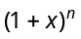 will be equal, if
(a) n is any integer (b) n is an odd integer
(c) n is an even integer (d) None of these
- If in the expansion of 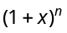, a, b, c are three consecutive coefficients, then n=
(a) 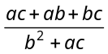 (b) 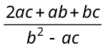
(c) 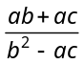 (d) None of these
- If n is positive integer and three consecutive coefficients in the expansion of are in the ratio 6 : 33 : 110, then n =
(a) 4 (b) 6
(c) 12 (d) 16
- The number of terms in the expansion of 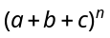 will be
(a) (b)
(c) 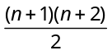 (d) None of these
- If the three consecutive coefficient in the expansion of are 28, 56 and 70, then the value of n is
(a) 6 (b) 4
(c) 8 (d) 10
- In the expansion of 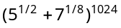, the number of integral terms is
(a) 128 (b) 129
(c) 130 (d) 131
- The number of terms which are free from radical signs in the expansion of 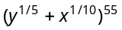is
(a) 5 (b) 6
(c) 7 (d) None of these
- Let 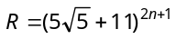 and 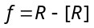, where [.] denotes the greatest integer function. The value of R.f is
(a) 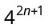 (b) 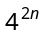
(c) 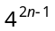 (d) 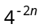
- The greatest integer less than or equal to 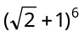is
(a) 196 (b) 197
(c) 198 (d) 199
- If number of terms in the expansion of 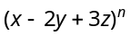are 45, then n=
(a) 7 (b) 8
(c) 9 (d) None of these
- Find the value of
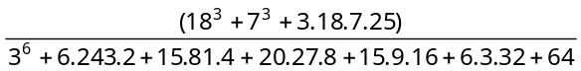
(a) 1 (b) 5
(c) 25 (d) 100
- If 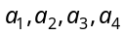 are the coefficients of any four consecutive terms in the expansion of , then 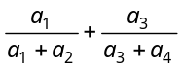 =
(a) 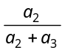 (b) 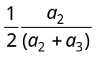
(c) 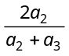 (d) 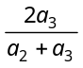
- The number of integral terms in the expansion of 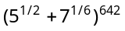 is
(a) 106 (b) 108
(c) 103 (d) 109
- The expression 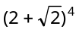 has value, lying between
(a) 134 and 135 (b) 135 and 136
(c) 136 and 137 (d) None of these
- The digit in the unit place of the number 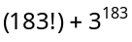 is
(a) 7 (b) 6
(c) 3 (d) 0
- The number of integral terms in the expansion of 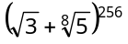 is
(a) 32 (b) 33
(c) 34 (d) 35
- If is the coefficient of 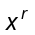, in the expansion of 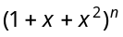, then 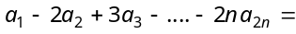
(a) 0 (b) n
(c) – n (d) 2n

- For all positive integral values of n, 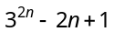 is divisible by
(a) 2 (b) 4
(c) 8 (d) 12
- If , then 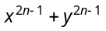 is divisible by
(a) (b)
(c) 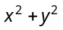 (d) 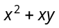
- If , then 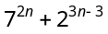. 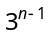 is always divisible by
(a) 25 (b) 35
(c) 45 (d) None of these

